**Second Payment Reminder**

To whom it may concern,

We got in touch recently to remind you that there is an outstanding payment due on this scheme.

We would appreciate it if you could contact us within the next 14 days of the date of this letter to arrange payment of the outstanding amount.

To ensure that the members of your group scheme are always fully covered, it is very important that your premium is paid as soon as possible.

If the payment has already been sent, please disregard this notice.

If you have any questions, please contact us by calling the Corporate Accounts team on 01 5625303 (Monday–Friday,9am–5pm) or by email corporate.accounts@irishlifehealth.ie and we’d be happy to help.

Yours sincerely,

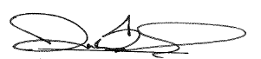

Darran Bennis

Senior Manager– Commercial Operations